**Basic Api Call documentation for NEW MemberActivity (Members area)**

**Created : 8-31-2013 ola lawal**

Important notes:

User profile must be first authenticated , and the profile id must be re-trived to use the services internal to Anewluv.

** Coming soon : API key will be required on an app per app basis to access the member services. So as you code note you might have to add the follow header to your JSON calls **

The Member Activity Page/Area

To access these API’s user must be validated via either OPEN ID ( face book, Yahoo,Google) or via the api with their username and password

**AuthenticationService.Docx** ( containes the documentation for required authentication calls)

List of API service calls within the authenciation service used to validate the user profile :

1. UserName and Password -

see AuthenticaionService APi document use the call : **validateuserbyusernamepassword**

1. OpenID/Email (i.e facebook , google , yahoo)

See AuthenticationServiceApi document use the call : **validateuserbyopenid**

**Main Service calls needed broken down by section**.

Steps -

Step 1) Authenticaiton

Once user is authenticated access to the MemberActivity page is allowed.

After the user is logged in either via registration APIs or the Login api the user’s profile ID should be cached or locally stored to be used with the API. To re-retrive the profile id see documentation in

MemberService.docx(containes documentation for the member service calls for getting individual profile data)

There are three ways to get the profile id similar to the authentication.

1. If the user name logged in with username/password use the following service call

See MemberService.docx use the call : **getprofileidbyusername**

1. If the user name logged in with Face book or open Id use the following service call

See MemberService.docx use the call : **getprofileidbyopenid**

1. If the user is already logged on or you do not have acces to either of those items above use

See MemberService.docx use the call : **getprofileidbyscreenname**

Step 2) Display Activity data based on activity type

This screen shows a summary

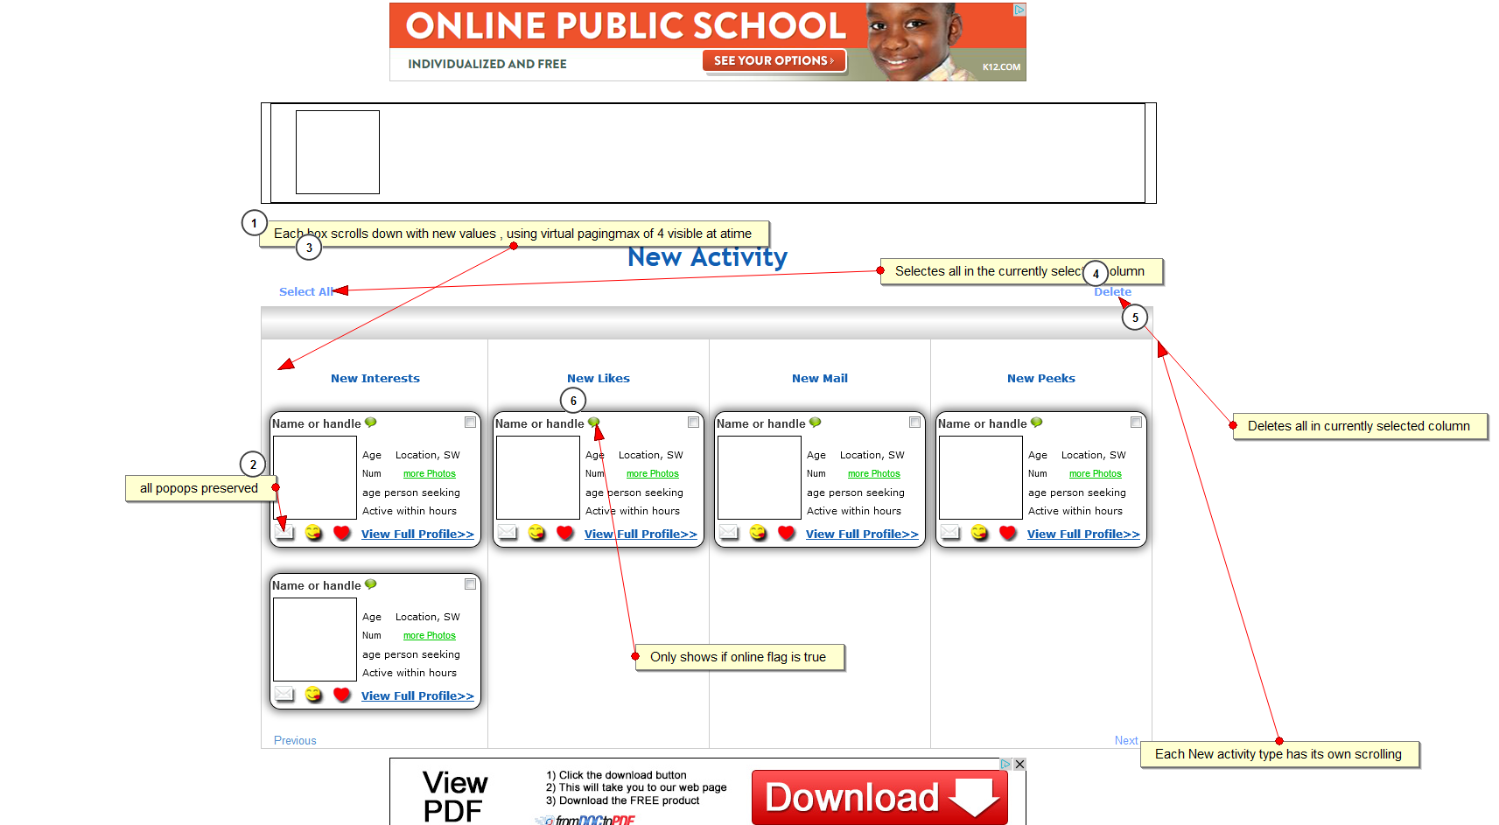

Coulums are populated similar to the the member activity documentation, the only diffrenece is all the service calls are made on this page.